Evidence Output

T009:

Valid first name case.

Input James in first name.

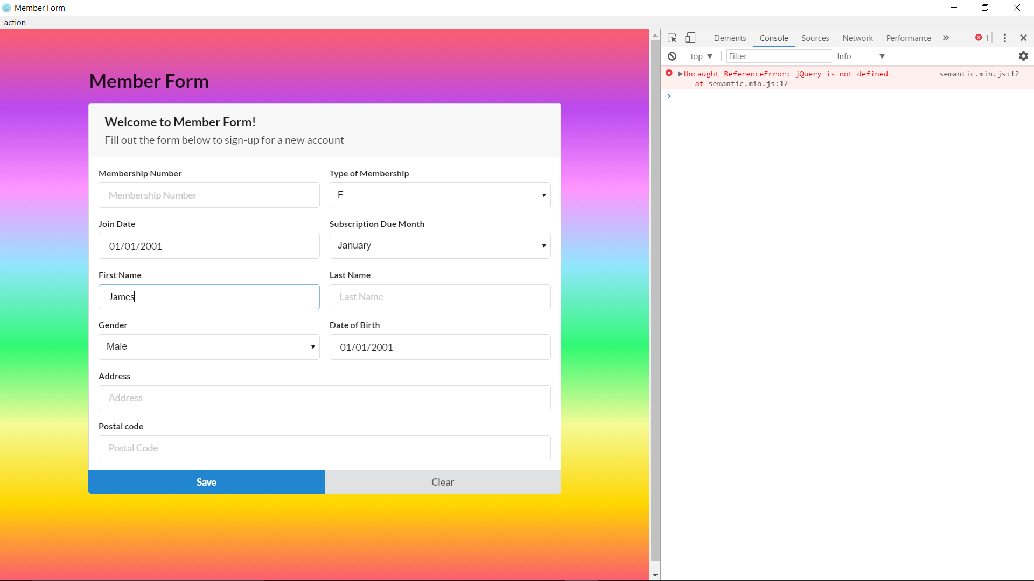

Valid first name case success.

